Solution Of Exercise 2: Introduction to Version Control

1. Git Setup:
Command: sudo apt install git
git –version [ To check whether git got installed or not?]
git config –global user.name DeepanjanTTN
git config –global user.email deepanjan.ghosh@tothenew.com

2. Initialize a Git Repository:
command: git init

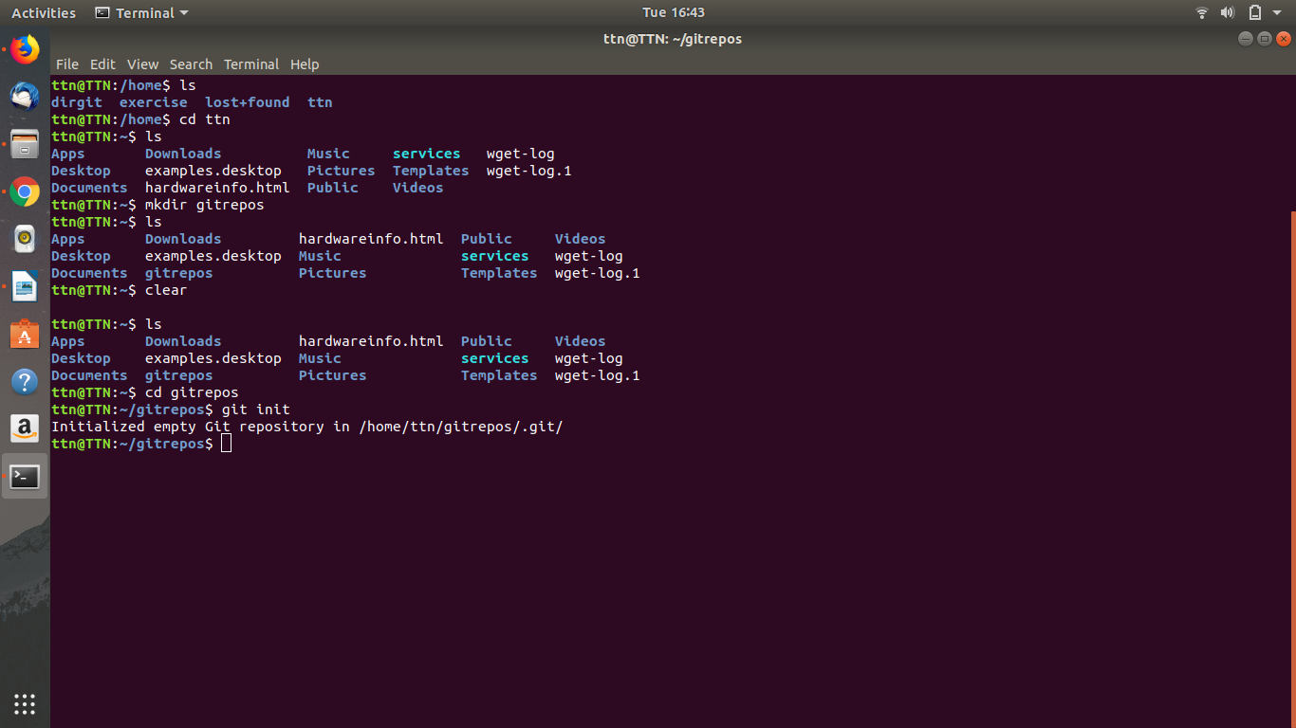

3. Add a file to repository:
Command: touch file1.txt
touch file2.txt
touch file3.txt
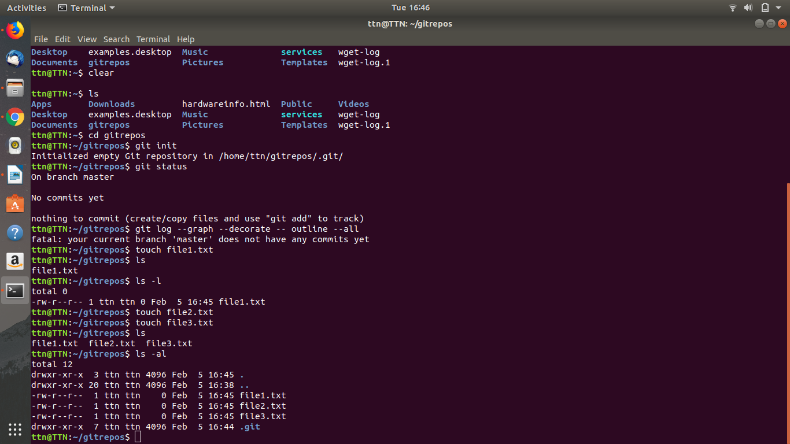

4. Unstage 1 file:
Command: git rm –cached file1.txt
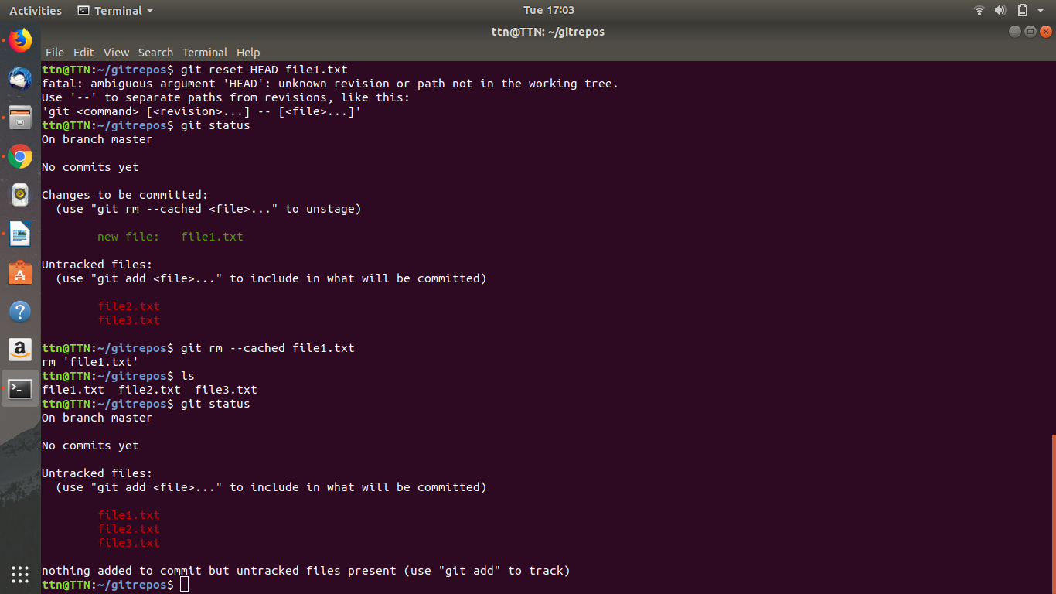

5. Commit the file:
command: git commit -m “File 1 Committed”
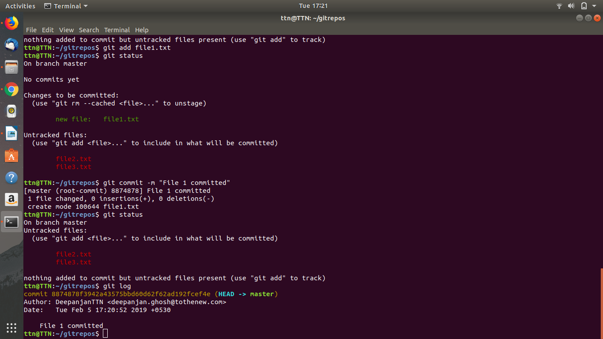

6. Add a remote:
Command: git remote add a https://github.com/DeepanjanTTN/repos1.git
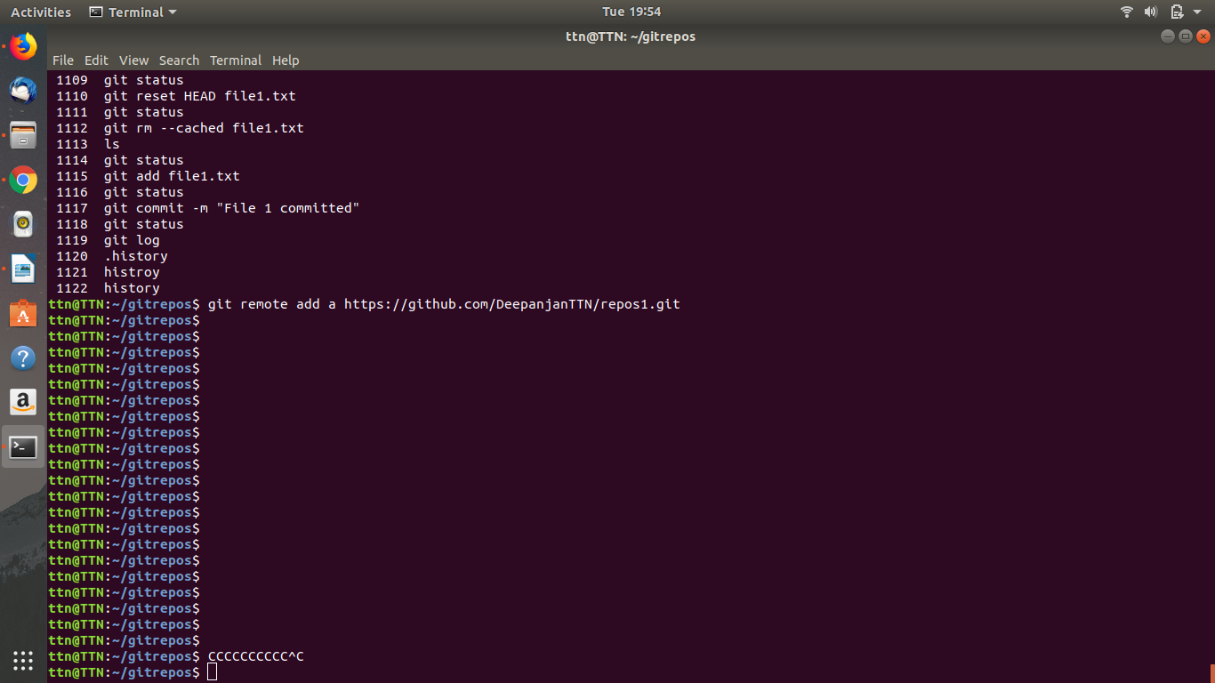

7. Undo changes to a particular file:
Command: gedit file2.txt [This command gives a edit box so we can change content in it to our according].
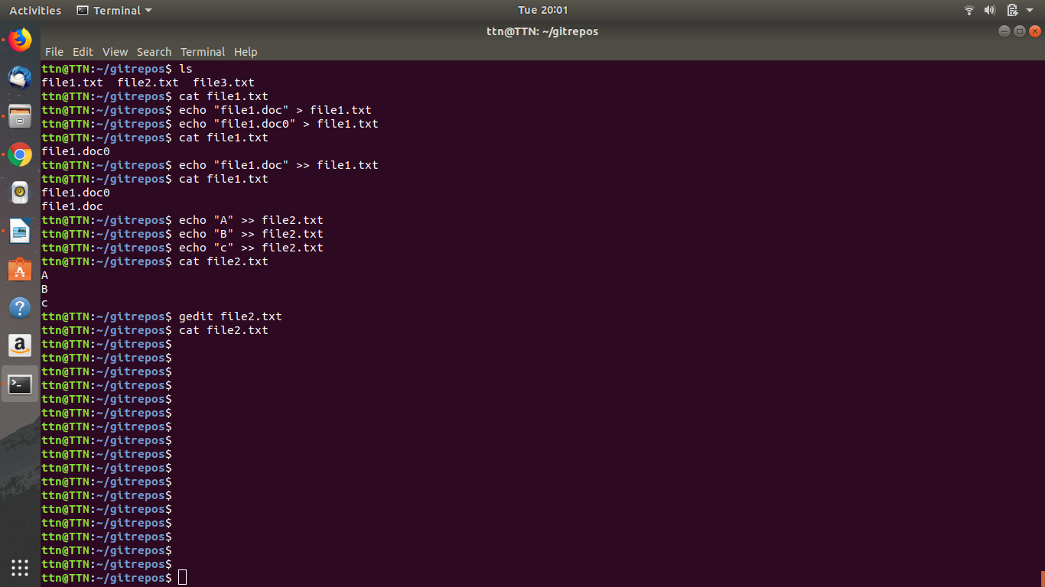

8. Push changes to github:
Command: git push origin master

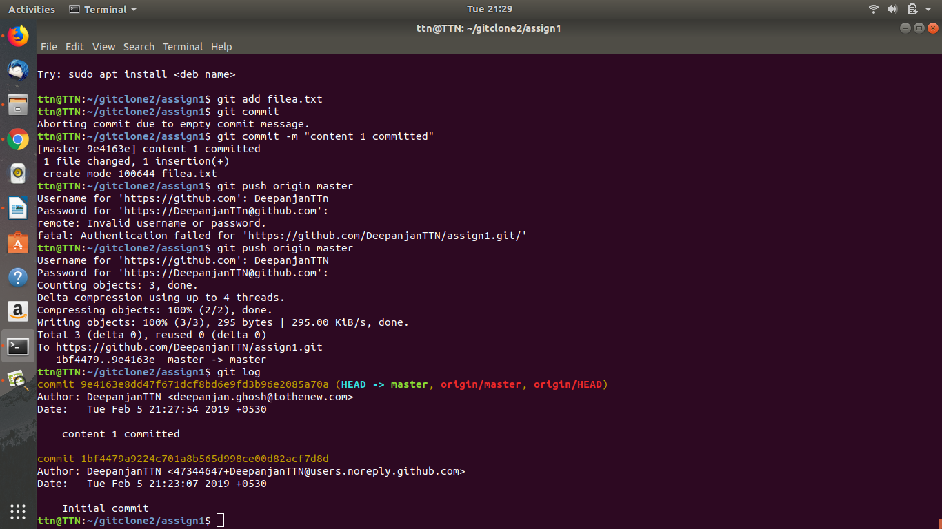

9. Clone the repository:
Command: git clone https://github.com/DeepanjanTTN/assign1.git
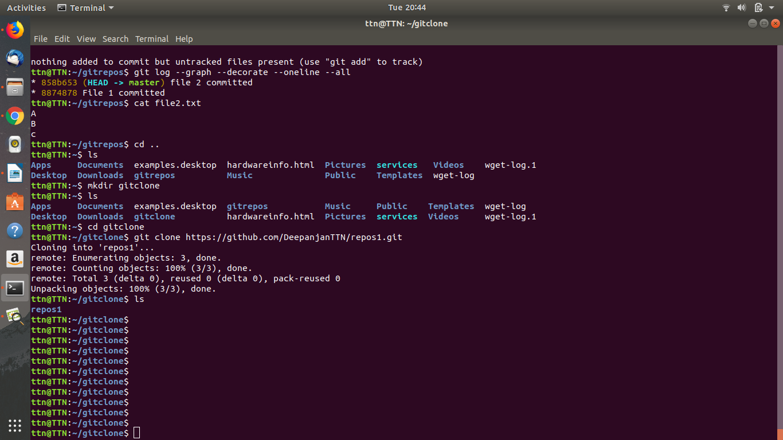

11. Check differences between a file and its staged version:
Command to bring a file in a staged version:
git add file3.txt

file3.txt before going to staged version can be seen in red color

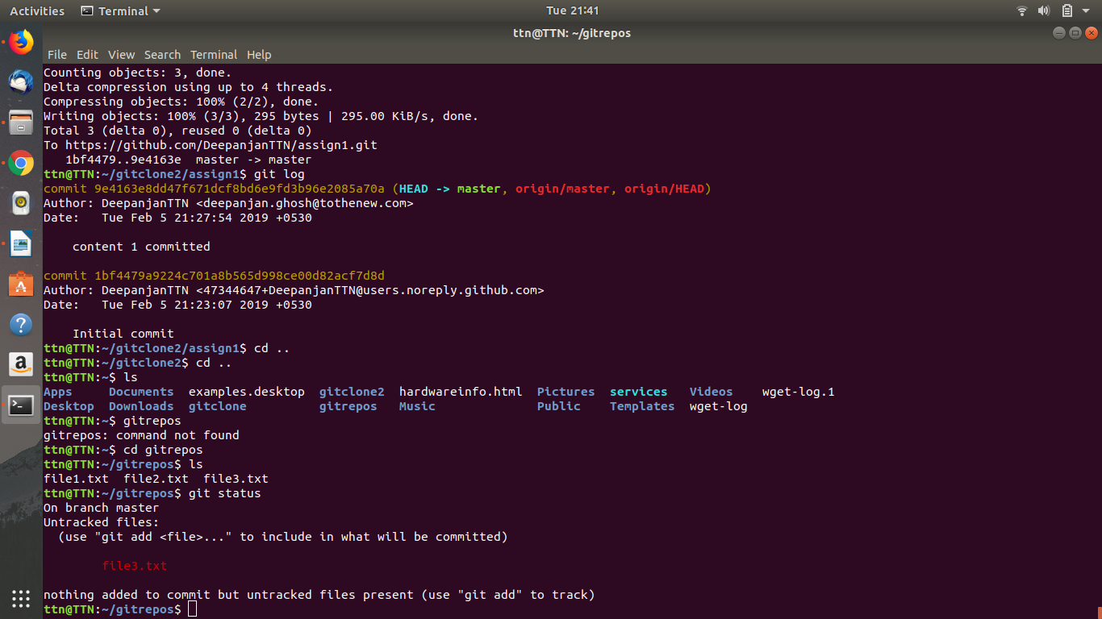

file3.txt after going in staged version bcome green color and gets ready to commit.
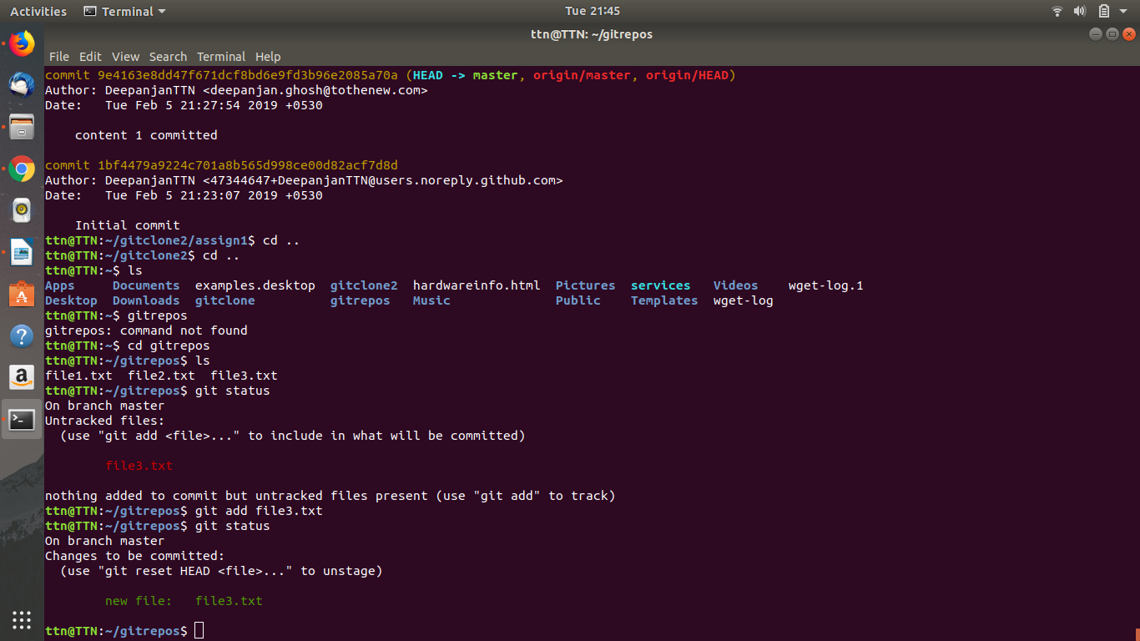
Files in stgaed version are ready to get commit

12. Ignore a few files to be checked in:
Command: touch .gitignore
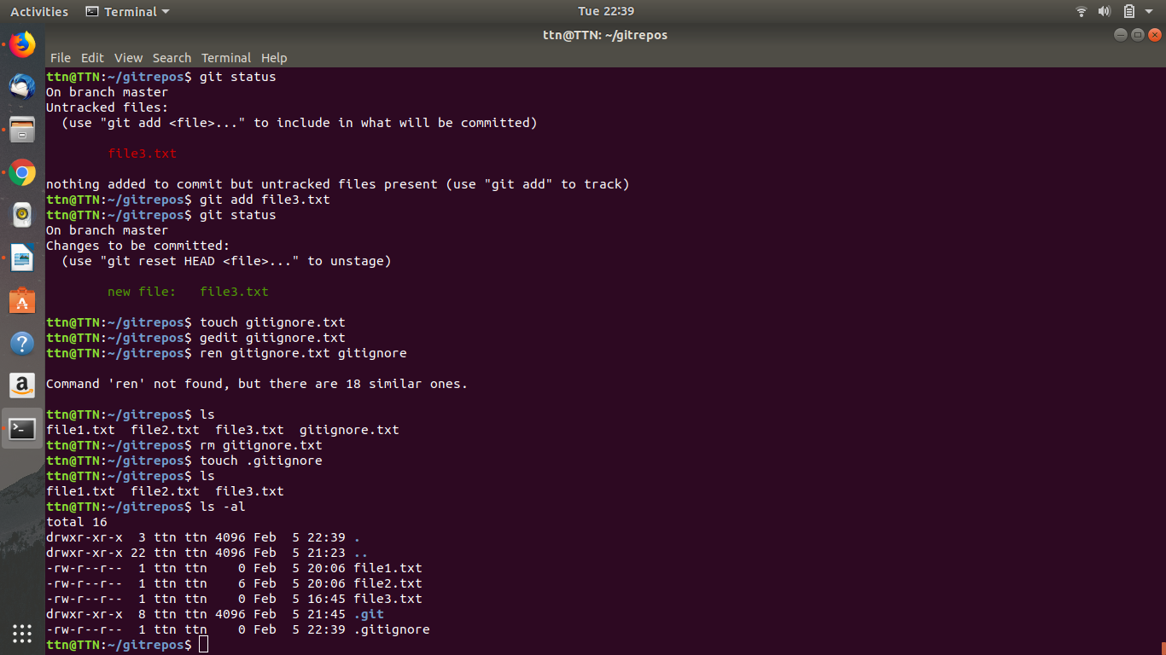

13 Create a new branch:
Command: git branch newb1
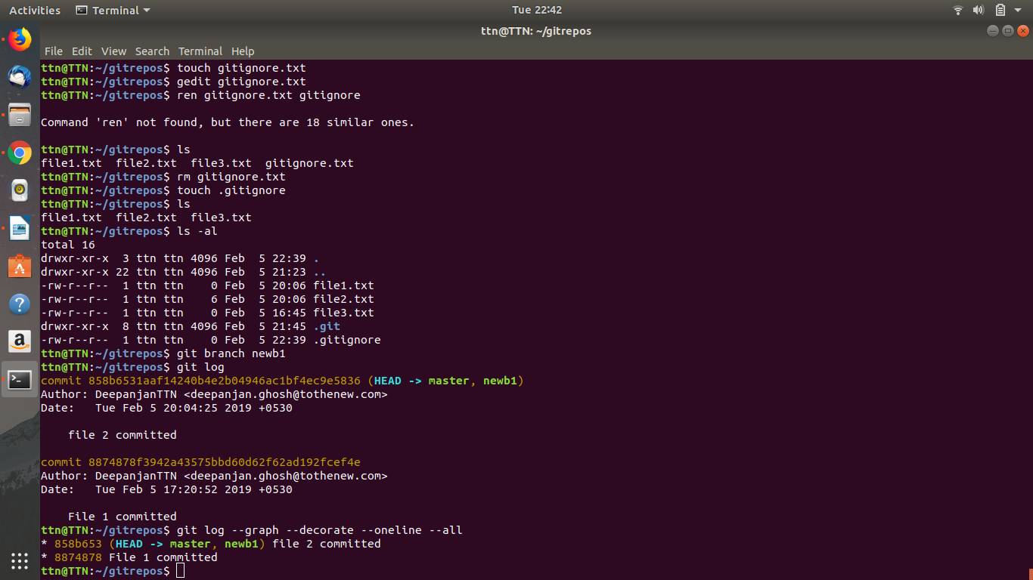

14. Diverge them with commits
Command: git add file4.txt [in a branch]
git commitfile4.txt
and then commit new file in master branch also
git add file 3.txt
git commit file4.txt
and then insert command git log –graph –decorate –oneline –all
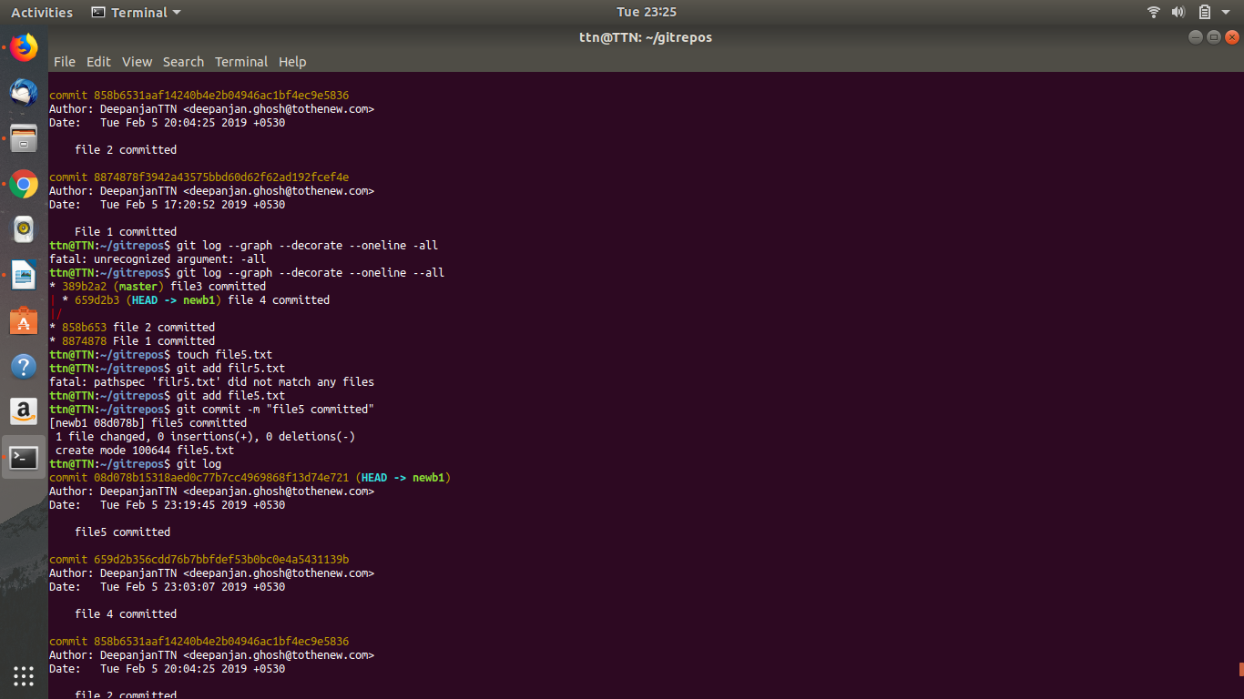

15.Edit the same file at the same line on both branches and commit:
Command: Create a new branch b4
git branch b4
ttn@TTN:~/gitrepos$ git checkout b4
Switched to branch 'b4'
ttn@TTN:~/gitrepos$ touch file9
ttn@TTN:~/gitrepos$ echo "A" >> file9
ttn@TTN:~/gitrepos$ echo "B" >> file9
ttn@TTN:~/gitrepos$ echo "C" >> file9
ttn@TTN:~/gitrepos$ git add file9
Create a new branch b5
git branch b5
ttn@TTN:~/gitrepos$ touch file9
ttn@TTN:~/gitrepos$ echo "A" >> file9
ttn@TTN:~/gitrepos$ echo "x" >> file9
ttn@TTN:~/gitrepos$ echo "C" >> file9
ttn@TTN:~/gitrepos$ git add file9
ttn@TTN:~/gitrepos$ git commit -m "file 9 committed"

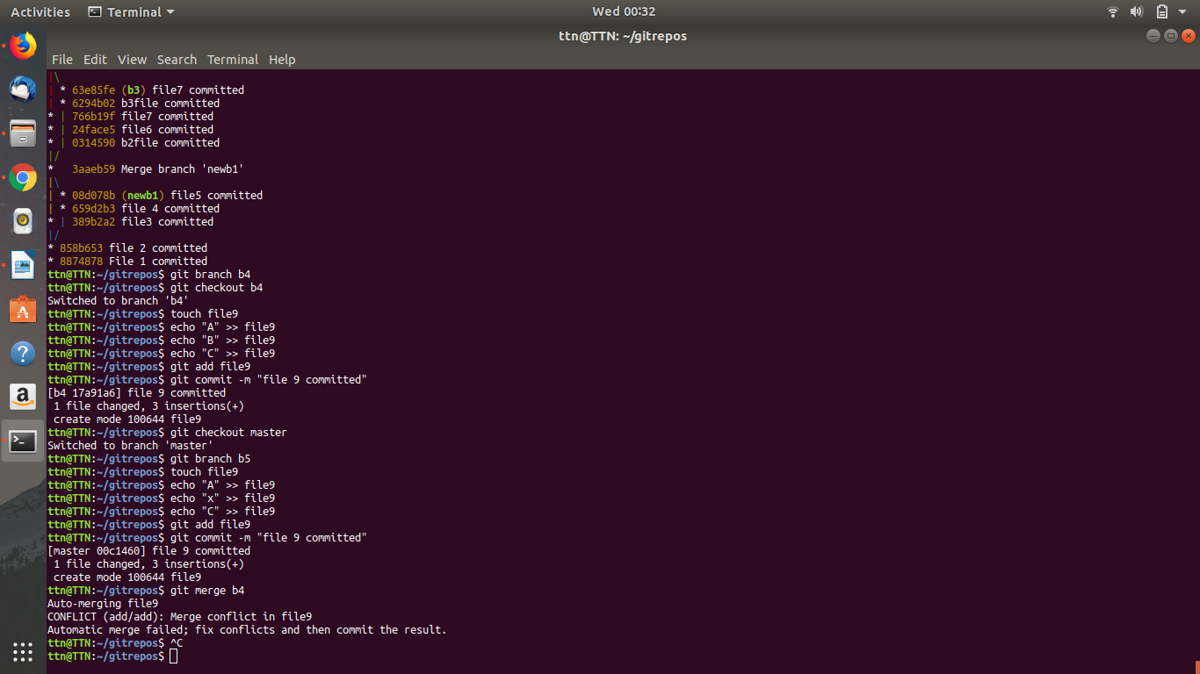

16. Try merging and resolve merge conflicts:
Command: git merge newb1
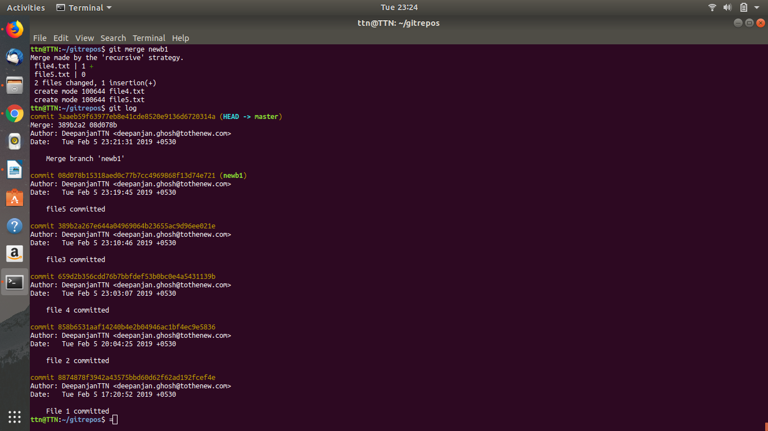
Command to resolve merge:
git merge b4
Auto-merging file9
CONFLICT (add/add): Merge conflict in file9
Automatic merge failed; fix conflicts and then commit the result.
ttn@TTN:~/gitrepos$ ^C
ttn@TTN:~/gitrepos$ git checkout --ours file9
ttn@TTN:~/gitrepos$ git add file9
ttn@TTN:~/gitrepos$ git commit -m "reolve merge"
[master bf7619e] reolve merge
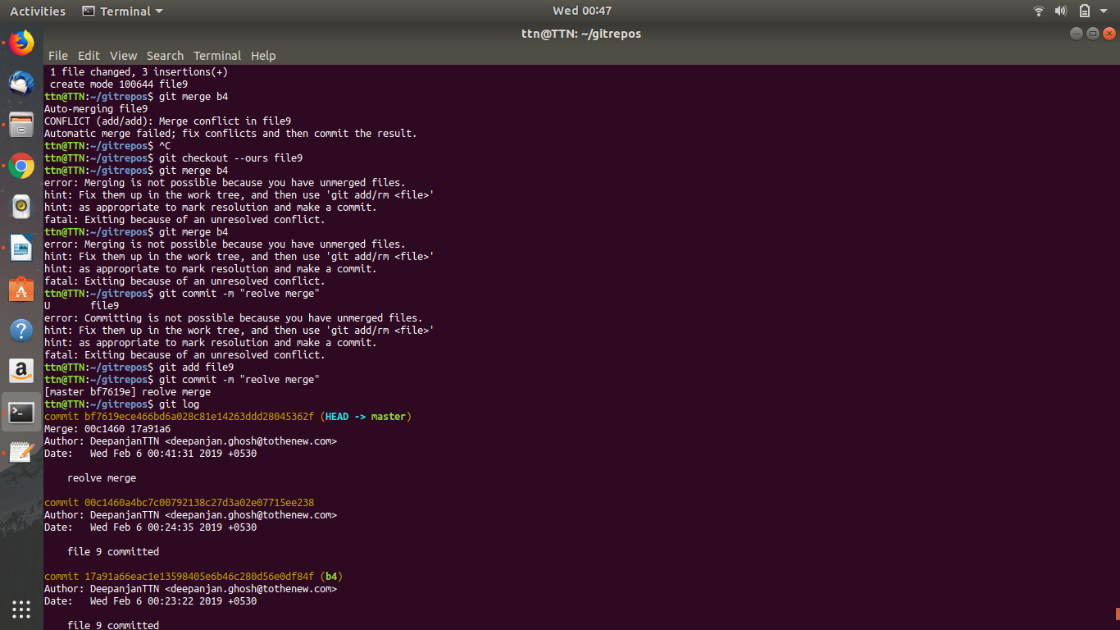
17.Stash the changes and pop them
Command:
Make change to a file9 so it becomes modified
then..
ttn@TTN:~/gitrepos$ git stash
Saved working directory and index state WIP on master: bf7619e reolve merge
to pop the stash
git stash pop
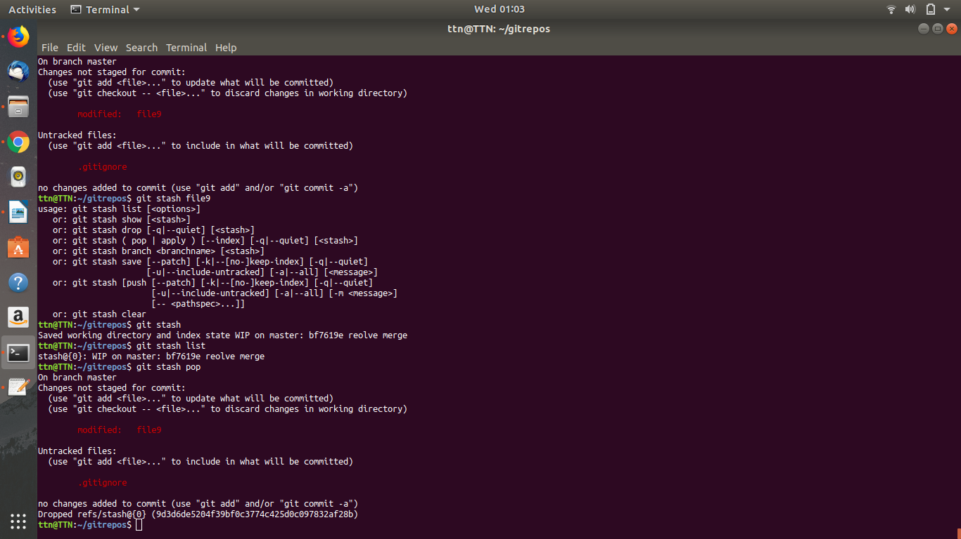

18.
